1. Find All Information About Departments Write a SQL query to find all available information about the departments. Sort the information by id. Submit your query statements as Prepare DB & run queries.

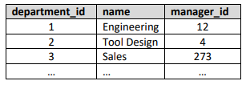

1. Find all Department Names Write SQL query to find all department names. Sort the information by id. Submit your query statements as Prepare DB & run queries.

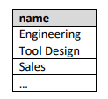

1. Find salary of Each Employee Write SQL query to find the first name, last name and salary of each employee. Sort the information by id. Submit your query statements as Prepare DB & run queries.

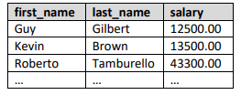

1. Find Full Name of Each Employee Write SQL query to find the first, middle and last name of each employee. Sort the information by id. Submit your query statements as Prepare DB & run queries.

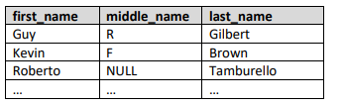

1. Find Email Address of Each Employee Write a SQL query to find the email address of each employee. (by his first and last name). Consider that the email domain is softuni.bg. Emails should look like “John.Doe@softuni.bg". The produced column should be named "full_ email_address". Submit your query statements as Prepare DB & run queries

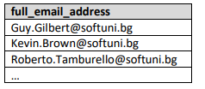

1. Find All Different Employee’s Salaries Write a SQL query to find all different employee’s salaries. Show only the salaries. Sort the information by id. Submit your query statements as Prepare DB & run queries.

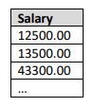

1. Find all Information About Employees Write a SQL query to find all information about the employees whose job title is “Sales Representative”. Sort the information by id. Submit your query statements as Prepare DB & run queries.

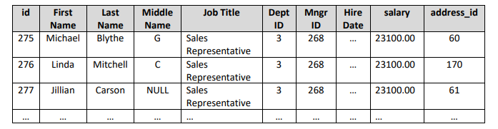

1. Find Names of All Employees by salary in Range Write a SQL query to find the first name, last name and job title of all employees whose salary is in the range [20000, 30000]. Sort the information by id. Submit your query statements as Prepare DB & run queries.

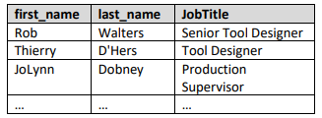

1. Find Names of All Employees Write a SQL query to find the full name of all employees whose salary is 25000, 14000, 12500 or 23600. Full Name is combination of first, middle and last name (separated with single space) and they should be in one column called “Full Name”. Submit your query statements as Prepare DB & run queries.

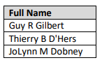

1. Find All Employees Without Manager Write a SQL query to find first and last names about those employees that does not have a manager. Submit your query statements as Prepare DB & run queries.

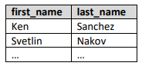

1. Find All Employees with salary More Than 50000 Write a SQL query to find first name, last name and salary of those employees who has salary more than 50000. Order them in decreasing order by salary. Submit your query statements as Prepare DB & run queries.

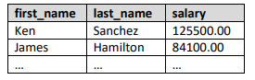

1. Find 5 Best Paid Employees Write SQL query to find first and last names about 5 best paid Employees ordered descending by their salary. Submit your query statements as Prepare DB & run queries.

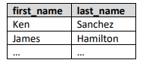

1. Find All Employees Except Marketing Write a SQL query to find the first and last names of all employees whose department ID is different from 4. Submit your query statements as Prepare DB & run queries.

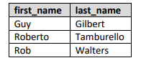

1. Sort Employees Table Write a SQL query to sort all records in the еmployees table by the following criteria: • First by salary in decreasing order • Then by first name alphabetically • Then by last name descending • Then by middle name alphabetically Sort the information by id. Submit your query statements as Prepare DB & run queries.

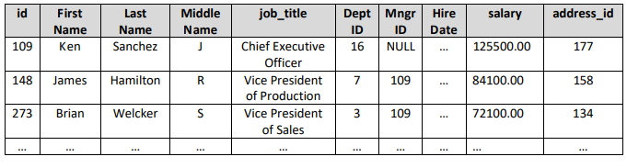

1. Create View Employees with Salaries Write a SQL query to create a view v_employees_salaries with first name, last name and salary for each employee. Submit your query statements as Run skeleton, run queries & check DB.

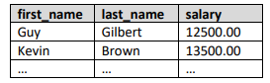

1. Create View Employees with Job Titles Write a SQL query to create view v_employees_job_titles with full employee name and job title. When middle name is NULL replace it with empty string (‘’). Submit your query statements as Run skeleton, run queries & check DB.

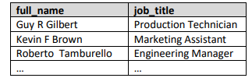

1. Distinct Job Titles Write a SQL query to find all distinct job titles. Sort the result by job title alphabetically. Submit your query statements as Prepare DB & run queries.

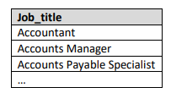

1. Find First 10 Started Projects Write a SQL query to find first 10 started projects. Select all information about them and sort them by start date, then by name. Sort the information by id. Submit your query statements as Prepare DB & run queries.

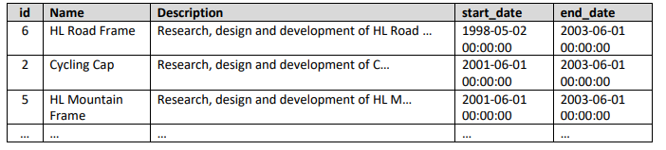

1. Last 7 Hired Employees Write a SQL query to find last 7 hired employees. Select their first, last name and their hire date. Submit your query statements as Prepare DB & run queries.

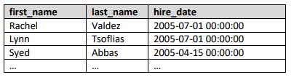

1. Increase Salaries Write a SQL query to increase salaries of all employees that are in the Engineering, Tool Design, Marketing or Information Services department by 12%. Then select Salaries column from the Employees table. Submit your query statements as Prepare DB & run queries.

